Name : Muhammad Haseeb Lab Task:02 Class : BSAI(3A)
Question no :01) PEAS is a framework of used to describe an intelligent agent environment . it stand for
Performance , environment , actuators and sensors .
- PEAS Specification: Delivery Robot :
Performance : Successful delivery to the correct destination . Safe operation with zero collisions or injuries . Delivery time and route efficiency .
Environment : Indoor corridors, lifts, doorways, and reception areas .People, other robots, carts, and temporary obstacles .
Actuators : Drive motors and steering mechanism to move and turn . Brakes or motor stop control for safe stopping
Sensors : depth camera to detect people, doors, and obstacles . Lidar or ultrasonic sensors to estimate distance to obstacles .
Constraints / Performance trade off : The robot must balance speed against safety. Moving faster can improve delivery time, but it reduces the time available to react to pedestrians and unexpected obstacles .
- PEAS Specification LLM – Based Student support Agent :
answer student questions about coursework, explain concepts, help plan study activities, and direct students to appropriate university services .
Performance : Response time and successful resolution of common question . Accuracy and relevance of answers, including correct acknowledgement of uncertainty.
Environment : Students using a web chat or university learning portal . Courses, assignment instructions, timetables, and approved learning resources .
Actuators : Generate text responses, summaries, examples, and step-by-step explanations . Ask clarifying questions and provide links to approved resources .
Sensors : Read the student’s typed message and conversation context . Receive uploaded text or documents only if file upload is enabled .
Constraints / Performance trade off : A more personalized answer may require more student data but collecting or retrieving extra data increases privacy and security threat .
Comparison and conclusion : The delivery robot acts physically, so collision avoidance, localization, and battery limits are central. The student-support agent acts mainly through information: accuracy, helpful explanations, privacy, academic integrity, and safe referral are central .
Question no 03):
- Observability: Fully observable or partially observable.
- Action outcomes: Deterministic or stochastic.
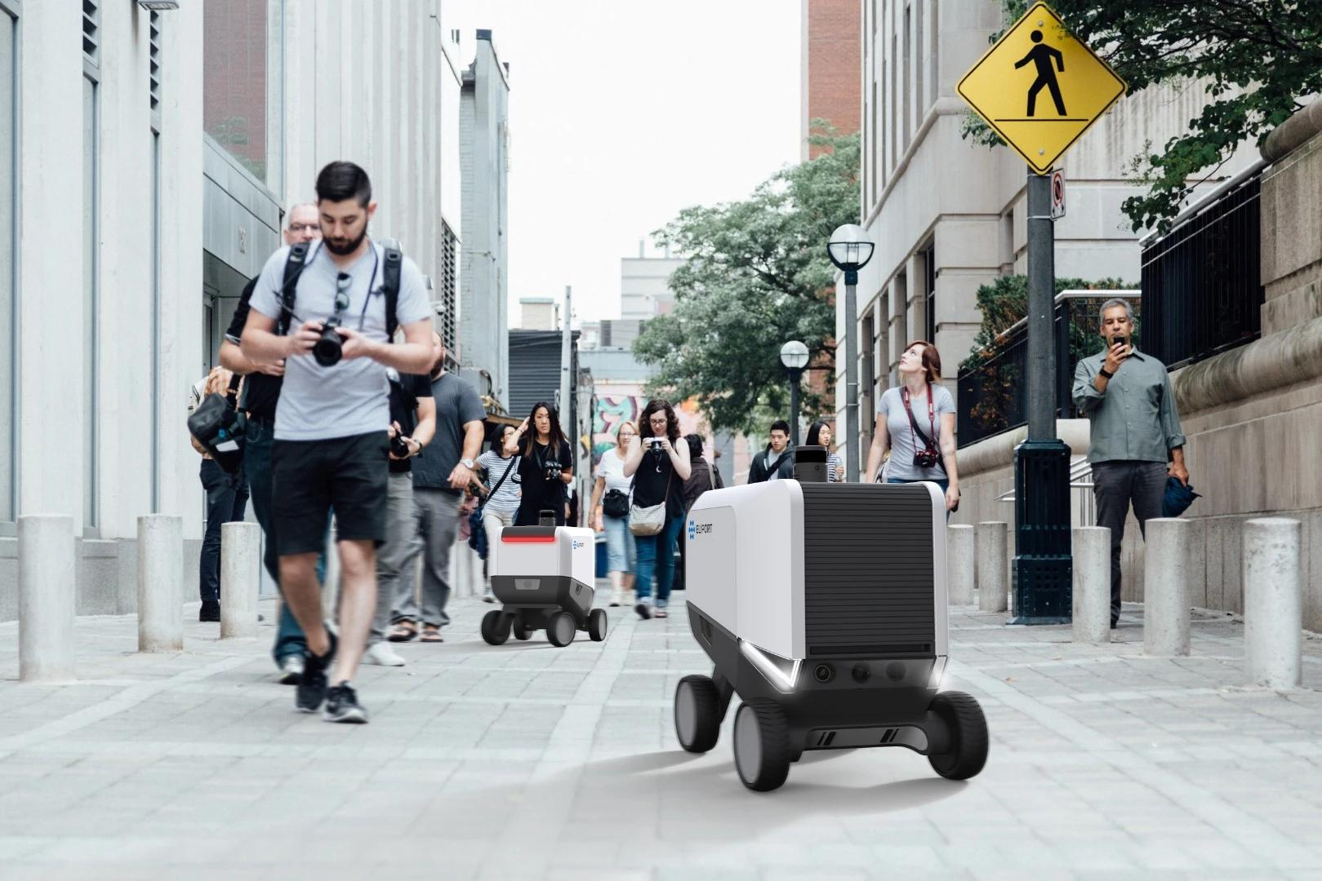
The robot delivers packages outdoors using cameras, GPS, obstacle sensors, and a navigation system .
Observability: Partially observable. The robot cannot observe every aspect of its environment at all times.
Determinism: Stochastic in the real world. The same movement command may produce different results because of slippery roads, weather, or sensor errors.
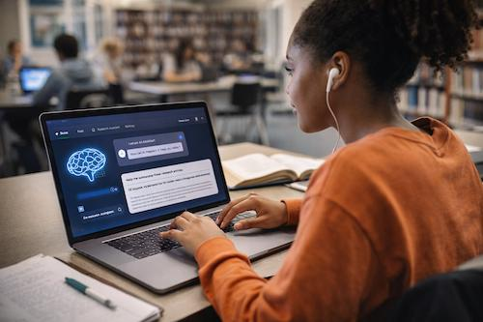
The agent answers students' academic questions using an LLM, the student's provided information, and authorized tools such as course materials, a calculator, and a university FAQ database .
Observability: Partially observable. The agent can observe the student's message and any supplied documents, but it may not know the student's actual understanding, intentions, emotional state, or missing course requirements.
Determinism: Stochastic in typical real-world operation. An LLM may generate different answers to thequestion, particularly when sampling is enabled. Tool failures or changing database contents may also affect results.
Simulator vs. real environment: In a simplified simulator, the agent may receive all relevant information and use fixed rules, making it fully observable and deterministic….

